Lab2:Assignment
Name : Parikshit Moin
RollNo:MCA2504030

Docker - Container Management
Lab 2 : Docker Container Lifecycle and Management Using Nginx
Step 1: Check Docker Installation
docker –version

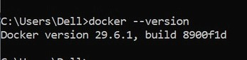
What is happening?
When you type: docker --version
Docker checks whether the DockerCLI(Command Line Interface) is installed on your computer. You
│
│ docker --version
▼
Docker CLI
│
▼
Displays Version
Example Output
Docker version 28.2.2, build 123456
This command doesnotcontactDockerHub or create anything . It simply checks the Docker program installed on your machine.

Step 2: Search for Nginx
docker search nginx
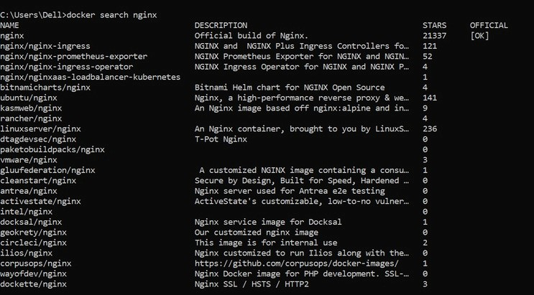
What happens?
Docker connects to Docker Hub, which is the official online repository for Docker images.
Your Computer
│
│ Search "nginx"
▼
Docker Hub
│
▼
Returns Matching Images
Example Output
NAME DESCRIPTION
nginx Official build of Nginx nginxinc/nginx bitnami/nginx
Why?
Docker images are stored online. Before downloading one, you can search for available images.
Think of Docker Hub like the Google Play Store or Apple App Store, but instead of apps, it stores Docker images.

Step 3: Download Nginx
docker pull nginx
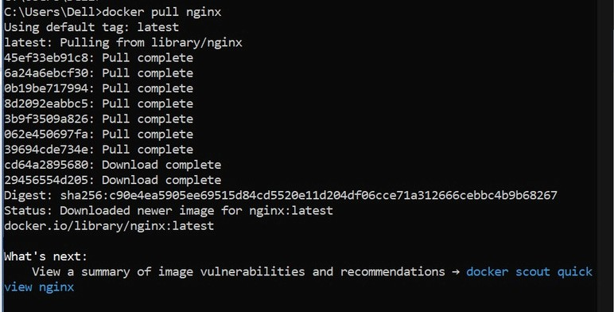
What happens?
Docker downloads the Nginx image from Docker Hub to your computer.
Docker Hub
│
│ Download Image
▼
Your Computer
│
▼
Stored in Docker Images
After downloading: docker images shows
REPOSITORY TAG nginx latest
Important
At this point:
❌ No container exists.
Only the image exists.
Think of it like:
Image = Software Installer
Container = Installed & Running Software

Step 4: View Images
docker images
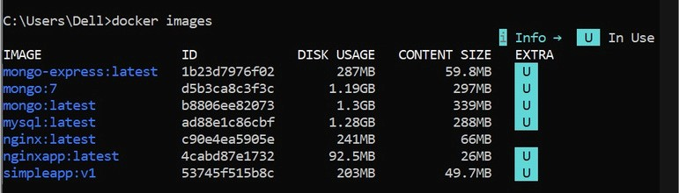
What happens?
Docker shows all downloaded images.
Example
IMAGE ID nginx ubuntu mysql
Nothing is running yet.
You only have installers.

Step 5: Run Nginx
docker run nginx
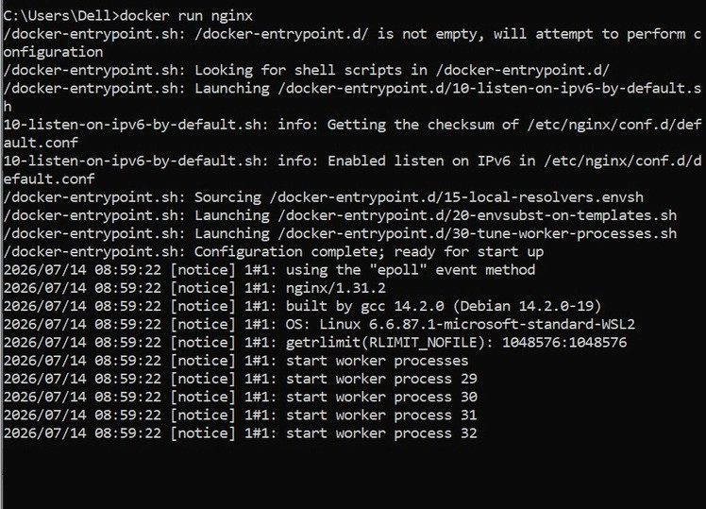
This is one of the most important Docker commands. What happens internally?
Docker performs several actions: Step A
Checks whether the image exists.
Is nginx image available?
YES
If not:
Docker automatically performs: docker pull nginx

Step B
Creates a new container from the image.
Image
↓
New Container
The image remains unchanged.
Containers are copies of the image. Step C
Starts the Nginx server.
Container
↓
Nginx Starts
Now Nginx is running inside the container.

Step D
Your terminal becomes attached to the running container.
Terminal
↓
Container Output
Stopping the program using Ctrl + C stops the container.

Step 6: Detached Mode
docker run -d nginx
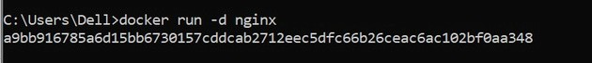
What changed?
-d
means
Detached Mode
Instead of connecting your terminal to the container:
Terminal
↓
Gets Prompt Back
The container continues running in the background.
Docker returns
9f3ab2c89c8d...
This is the Container ID.

Step 7: Name the Container
docker run -d --name mynginx nginx
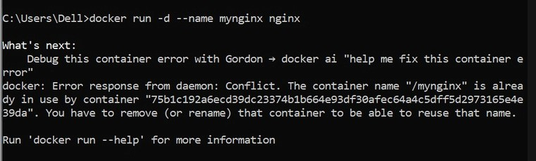
Without a name:
Docker generates random names. Example adoring_pike crazy_turing happy_einstein
Using --name mynginx makes management easier. Instead of docker stop 98ab123... you simply type docker stop mynginx

Step 8: Publish a Port
docker run -d --name webserver -p 8080:80 nginx
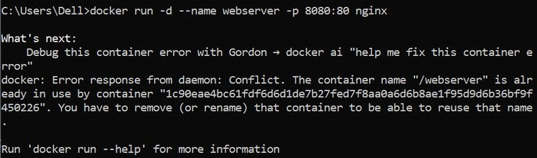
This is the most important networking concept.
Inside the container Nginx always listens on
Port 80
Container
Nginx
↓
80
But your computer cannot automatically access that internal port.
So Docker creates a mapping.
Computer
8080
↓
Container
80
Meaning localhost:8080
↓
Container Port 80
Opening
http://localhost:8080 actually forwards the request to
Container
↓
Nginx
↓
Port 80

Step 9: List Running Containers
docker ps
Shows
Container ID
Image
Status
Ports
Name Example mynginx
Up 5 minutes
0.0.0.0:8080->80
Meaning
Host Port
8080
↓
Container Port
80

Step 10: Stop Container
docker stop mynginx
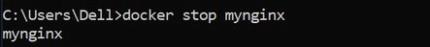
Docker sends a signal to Nginx.
Please Stop Gracefully
Nginx saves its state and exits cleanly.
Container Status
Running
↓
Exited
Notice:
The containerisnot deleted.
It is only stopped.

Step 11: Start Container Again
docker start mynginx
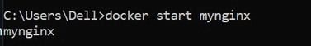
Docker does notcreate a new container.
It simply starts the existing one.
Stopped Container
↓
Running Container

Step 12: Restart
docker restart mynginx
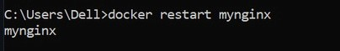
Equivalent to docker stop mynginx docker start mynginx

Step 13: View Logs
docker logs mynginx
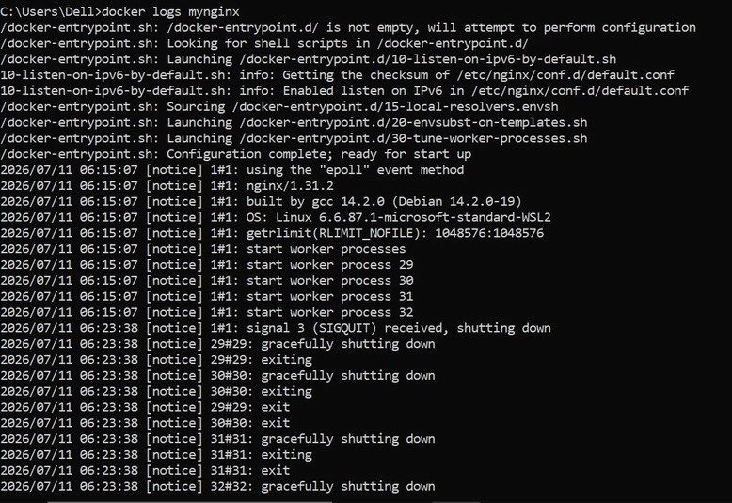
Every application writes messages.
Example
Nginx Started
Request Received
Response Sent Docker stores these logs.
Useful for debugging.

Step 14: Enter the Container
docker exec -it mynginx bash
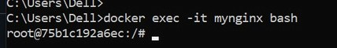
This command opens a shell inside the running container.
Your Computer
↓
Docker
↓
Container
↓
Linux Bash Now commands like
pwd
ls
cd /usr/share/nginx/html are executed inside the container, not on your Windows machine.
This is very useful for troubleshooting or inspecting files.

Step 15: Remove the Container
docker rm mynginx
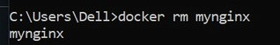
Docker deletes the container only.
Container
❌ Deleted
The image is still available.
You can create a new container anytime using: docker run nginx

Step 16: Remove the Image
docker rmi nginx
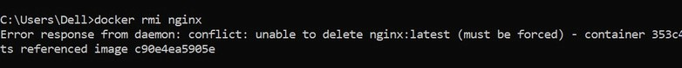
Now Docker removes the downloaded image from your local system.
Image
❌ Deleted
If any container still depends on that image, Docker will refuse to remove it until those containers are deleted.

